Front axle model

# 1 System description

Model of the Front axle. The model includes the internal combustion engine and the control system associated, and a transmission composed of a clutch, a gearbox and a differential.

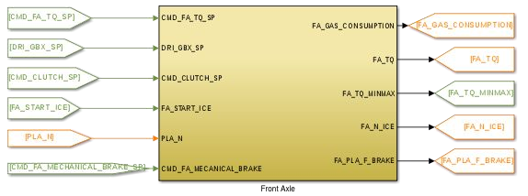

# 2 System organization

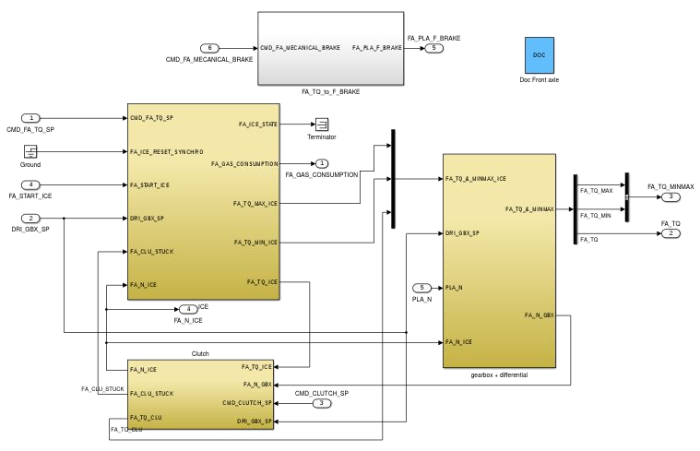

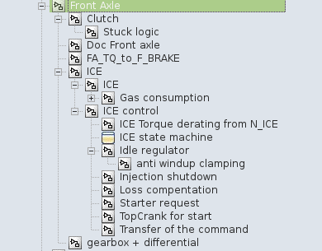

Model browser

# 3 Signals and parameters

## Inputs

|  |  |  |
| --- | --- | --- |
| Name | Description | Note |
| PLA_N | Wheel speed | In RPM |
| CMD_FA_TQ_SP | Torque set point for the ICE | In N.m |
| CMD_FA_MECHANICAL_BRAKE_SP | Torque set point of mechanical brake of front axle | In N.m |
| DRI_GBX_SP | Gearbox engaged gear | For a manual gearbox |
| DRI_CLUTCH_SP | Clutch pedal value | Range [0, 1] |
| FA_START_ICE | Starts the engine | - |

## Outputs

|  |  |  |  |
| --- | --- | --- | --- |
| Name | Description | Note | Destination |
| FA_GAS_CONSUMPTION | Instantaneous gas consumption | - | Command |
| FA_TQ | Torque to wheel from the front axle | - | Platform |
| FA_PLA_F_BRAKE | Force set point of mechanical brake of front axle | In N | Platform |
| FA_TQ_MINMAX | Minimum and maximum torque for the ICE | Normalized torque “to wheel”,  two signal:   * FA_TQ_MIN * FA_TQ_MAX | Command |
| FA_N_ICE | Rotation speed of the ICE | In rpm | Driver |

## Parameters

### Native

|  |  |  |  |  |  |
| --- | --- | --- | --- | --- | --- |
| Name | Type | Unit | Description | Source | Linked to |
| fa_clu_pos | vector | Nm | Clutchmaximum transmitted torque | Internship 2014 | fa_clu_pv |
| fa_clu_pv | vector | - | Clutchpedal position | Internship 2014 | fa_clu_pos |
| fa_conso_speed | vector | RPM | ICE speed input vector for gas consumption | Continental | fa_conso_torque; fa_fuel_consumption |
| fa_conso_torque | vector | Nm | ICE torque input vector for gas consumption | Continental | fa_conso_speed; fa_fuel_consumption |
| fa_differential_ratio | var | - | Front axledifferential ratio | Continental |  |
| fa_fuel_consumption | table | g | ICE gasconsumption | Continental | fa_conso_torque; fa_conso_speed |
| fa_gearbox_ratio | vector | - | Gearbox ratio | Continental |  |
| fa_gearbox_efficiency | var | - | Gearboxefficiency | Continental |  |
| fa_ice_inertia | var | kg.m² | Engine inertia | Continental |  |
| fa_kp_idle_tr_off | var | - | Idle controller parameter – Kp transmission off | Internship 2014 |  |
| fa_kp_idle_tr_on | var | - | Idle controller parameter – Kp transmission on | Internship 2014 |  |
| fa_max_tq_clu | var | Nm | Maximum transmitted torque for the clutch | Internship 2014 |  |
| fa_max_tq_ice | vector | Nm | Maximum ICE torque | Continental | fa_tq_max_speed |
| fa_n_ice | vector | RPM | ICE speed input vector for ICE loss | Continental | fa_tq_loss |
| fa_starter_rpm | vector | RPM | Starter speed input vector for starter torque | Continental | fa_starter_tq |
| fa_starter_tq | vector | Nm | Starer torque | Continental | fa_starter_rpm |
| fa_tau_ice | var | s | ICE time constant | BEI N7 2014 |  |
| fa_taui_idle_tr_off | var | s | Idle controller parameter – Ti transmission off | Internship 2014 |  |
| fa_taui_idle_tr_on | var | s | Idle controller parameter – Ti transmission on | Internship 2014 |  |
| fa_tq_loss | vector | Nm | ICE loss | Continental | fa_n_ice |
| fa_tq_max_speed | vector | RPM | ICE torque input vector for ICE maximum speed | Continental | fa_max_tq_ice |

### Inherited

|  |  |  |  |  |  |
| --- | --- | --- | --- | --- | --- |
| Name | Type | Unit | Description | Source | Linked to |
| pla_wheel_radius | var | m | Wheel radius (includes tire deformation) | BEI N7 2014 |  |

# 4 Subsystems description

Gearbox + differential

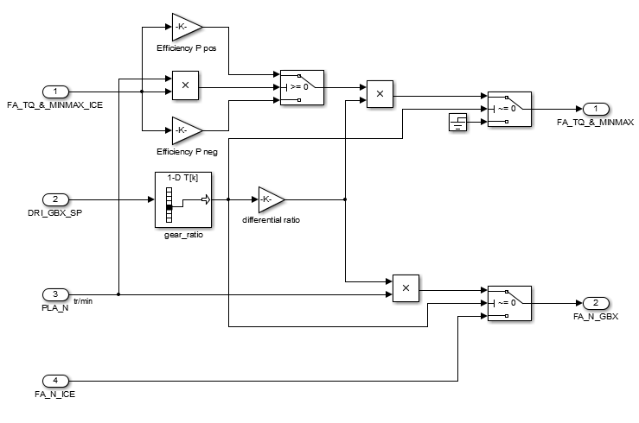

Clutch

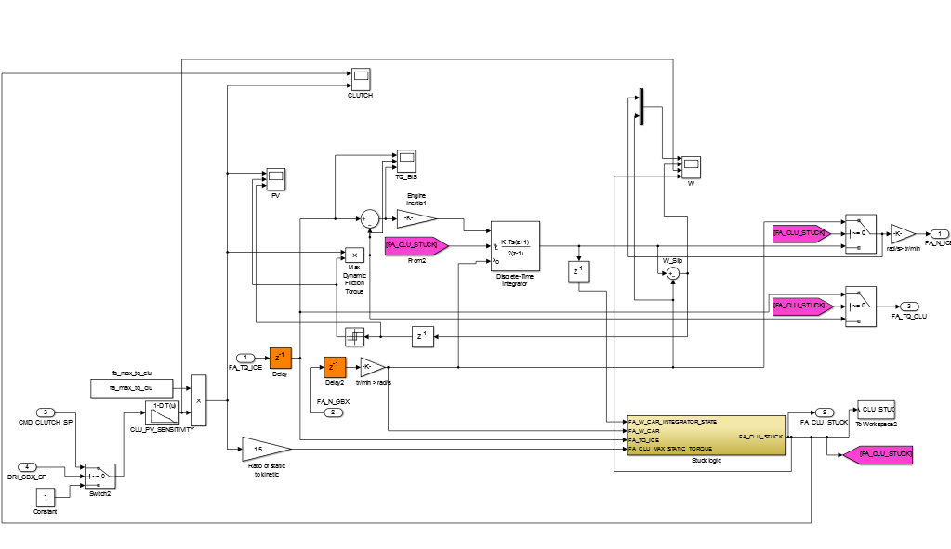

Stuck logic

Determine if the clutch is open/slipping or stuck.

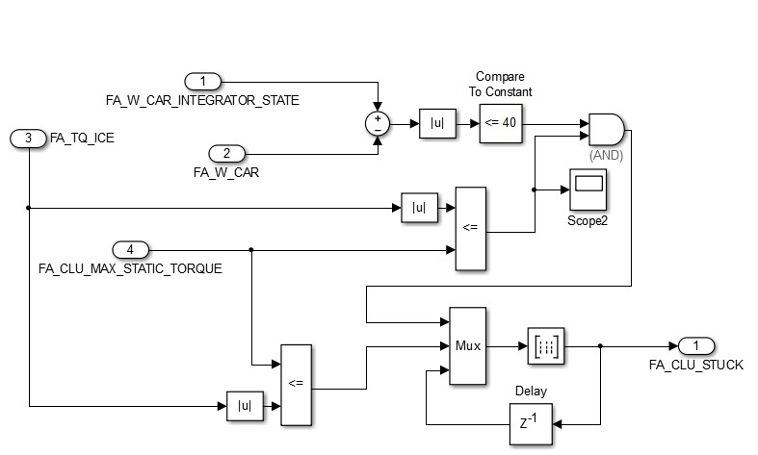

The objective of the stuck logic is to determine if the clutch is slipping or not. If the torque of the ICE is higher than the the maximum clutch static torque, the clutch is slipping. If the torque of the ICE is lower than the the maximum clutch static torqueand the speed of the gearbox and the speed of the ICE are different, the clutch is slipping. If both conditions are true the past state is used.

The truth table is the following :

|  |  |  |  |
| --- | --- | --- | --- |
| TQ_ICE >= TQ_STATIC_MAX | TQ_ICE <= TQ_STATIC_MAX & N_ICE ≠ N_GBX | z-1 | CLUTCH_STUCK |
| 0 | 0 | 0 | 0 |
| 0 | 0 | 1 | 1 |
| 0 | 1 | 0 | 0 |
| 0 | 1 | 1 | 0 |
| 1 | 0 | 0 | 1 |
| 1 | 0 | 1 | 1 |
| 1 | 1 | 0 | 0 |
| 1 | 1 | 1 | 1 |

The speed of the gearbox and the speed of the ICE are consider equal when the difference between them is less than 40 rpm (see FA_W_CAR_INTEGRATOR_STATE &FA_W_CAR).

Internal combustion engine

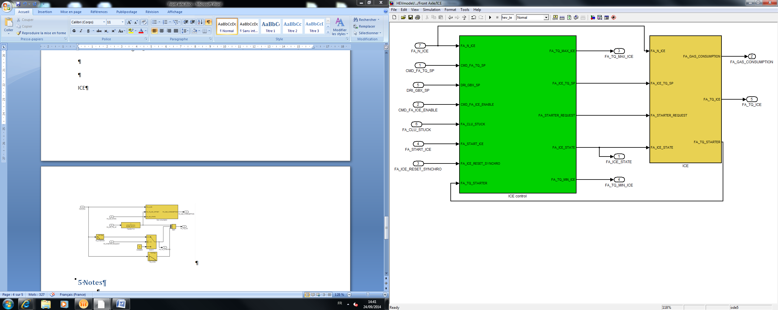

ICE

Behavior of the ICE (torque generation and fuel consumption)

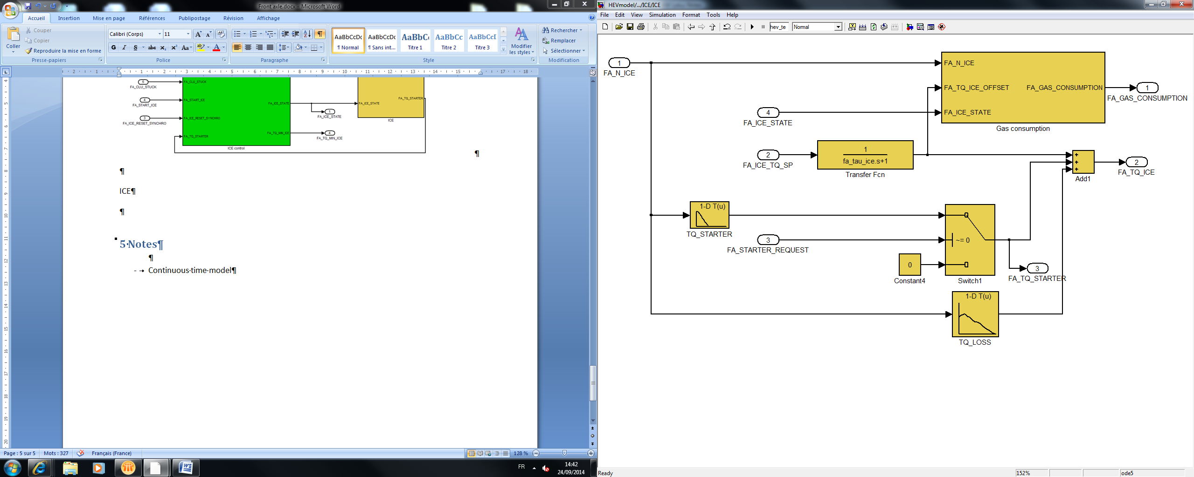

Gas consumption

Estimation of the instantaneous fuel consumption.

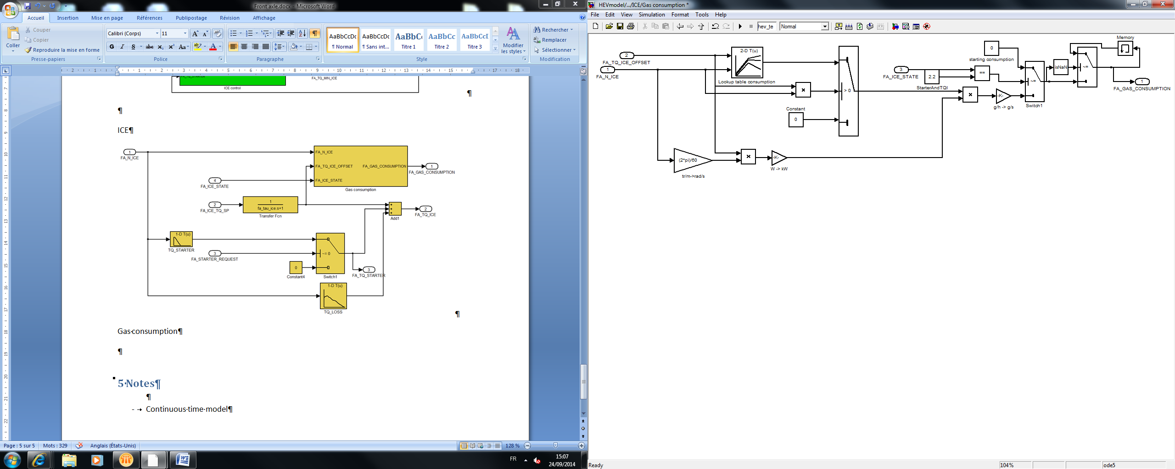

ICE control

Control of the ICE. Determines the running mode and the torque set point.

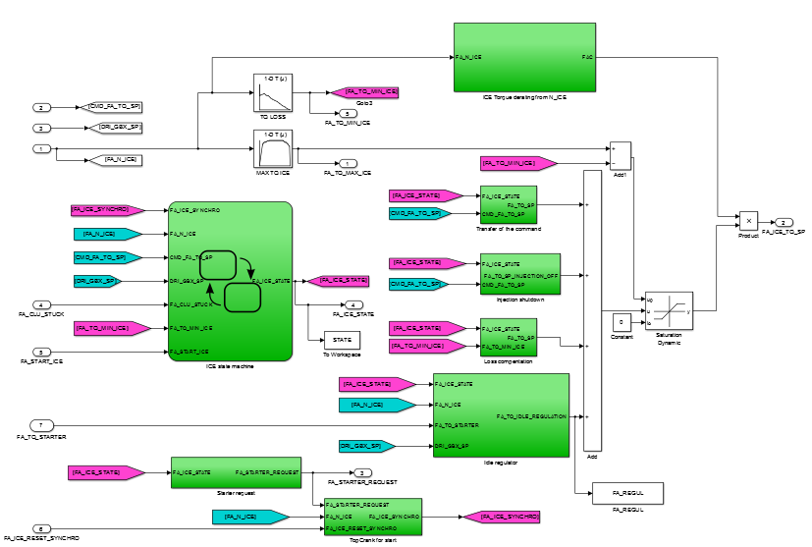

ICE_TORQUE DERATING FROM N_ICE

The derating is used in case of overspeed of the ICE. It regulates the speed at a determined value. The lower the slope, the lower the oscillations. The slope is calculated for being at the limit of oscillations (overshoot of 10 rpm).

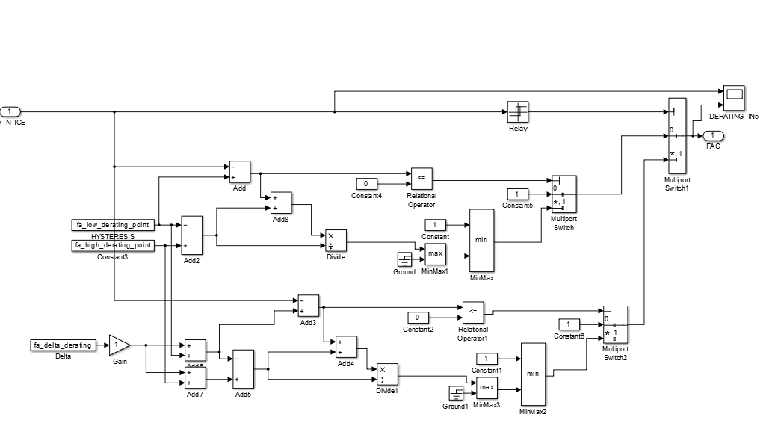

Transfer of the command

Copy the command set point.

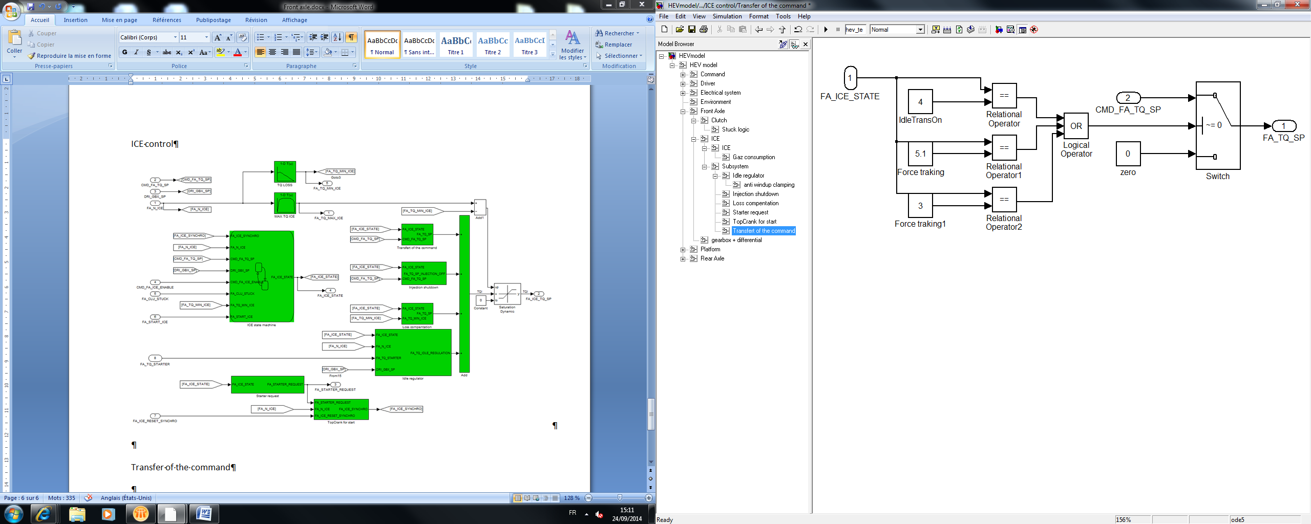

Injection shutdown

Create a set point with a determined slew rate on a quick decrease of the driver set point to the minimum.

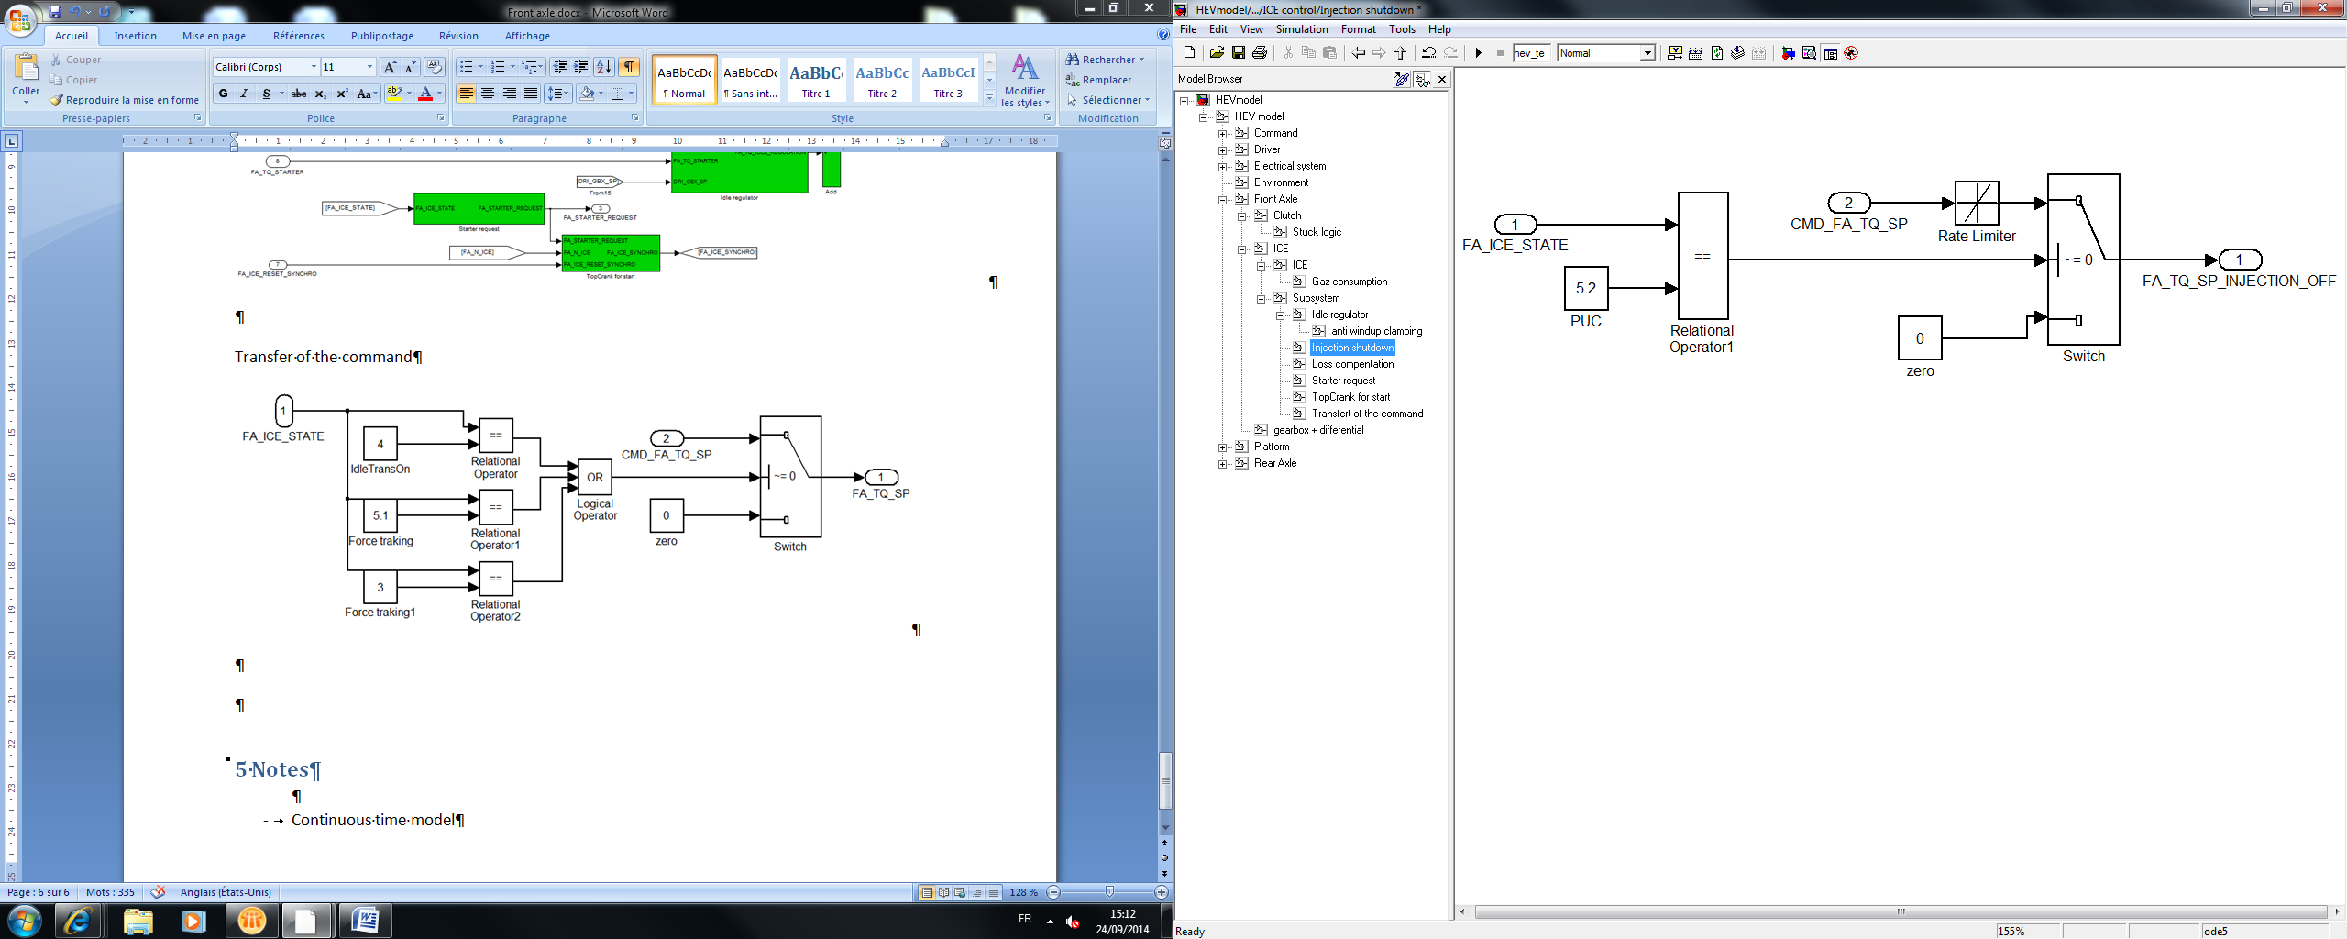

Loss compensation

Compensation of the ICE loss on running set point.

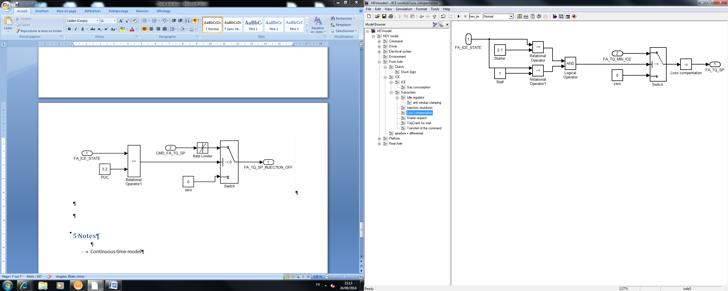

Starter request

Sent an enable signal to the starter.

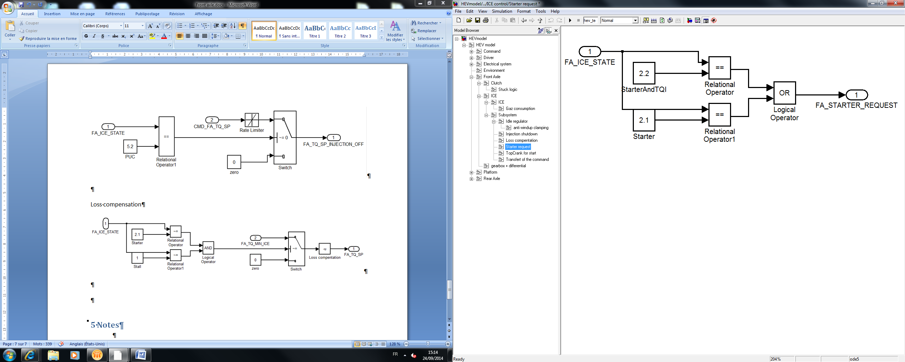

TopCrank for start

Estimation of the crank position for ECU synchronization.

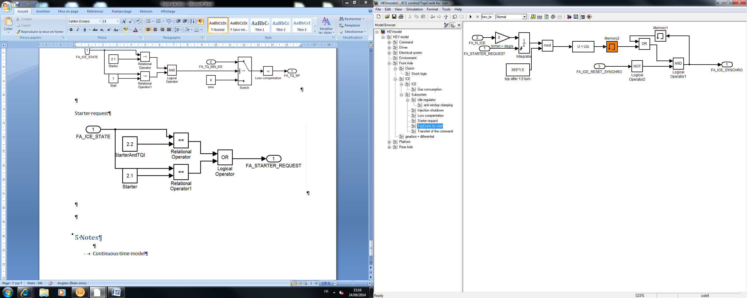

Idle regulator

Idle speed regulator, based on a PI with coefficient depending of the ICE mode. Include a compensation for the Starter toque.

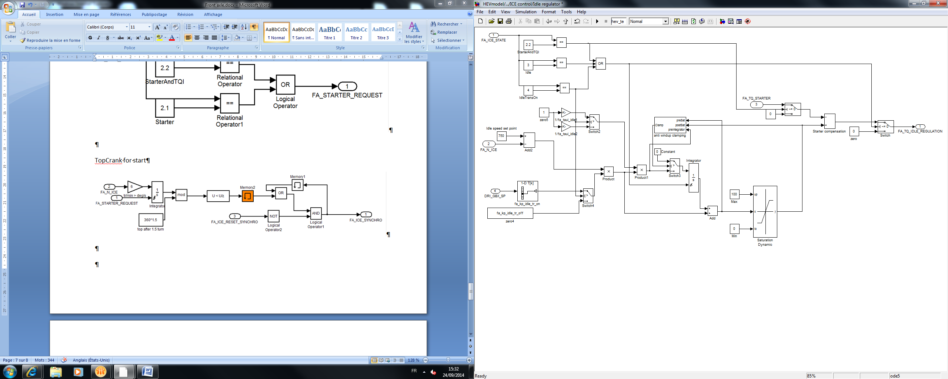

Braking Torque to force conversion

Convert torque to wheel braking to force braking

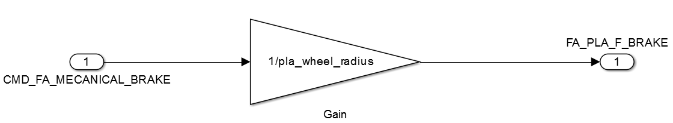

# 5 Discrete model

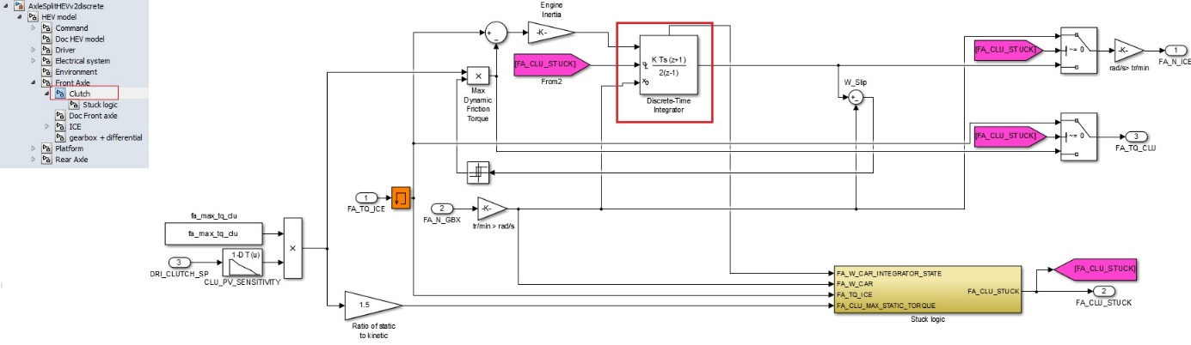

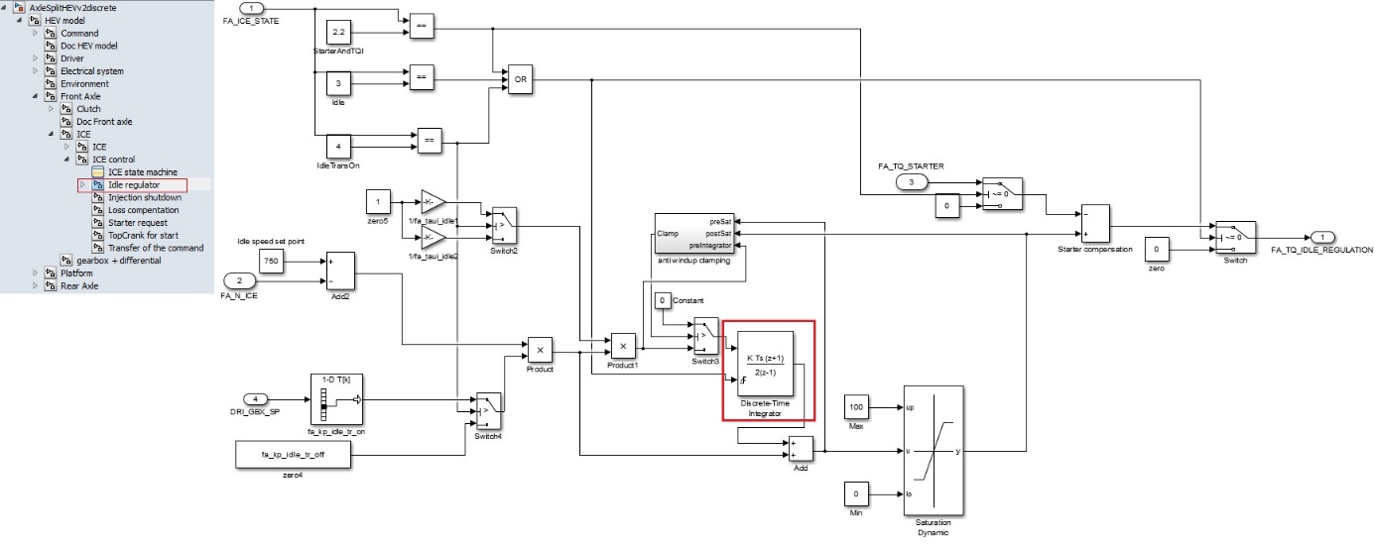

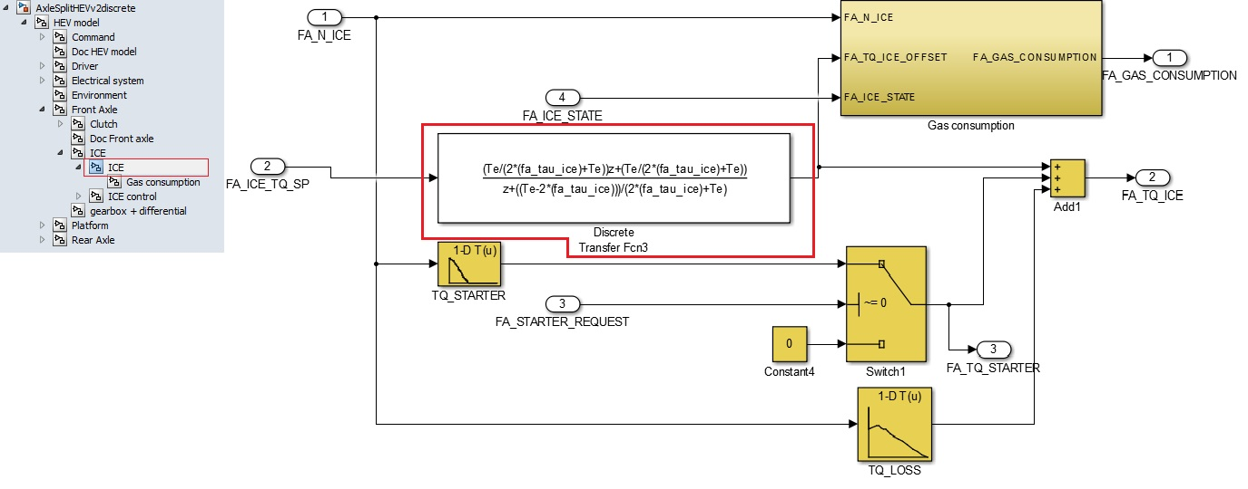

Same inputs, outputs and parameters. The only changes are in the red squares.

See part 5 (“Discrete model”) of the document “HEV model” to know how are made the discrete blocs.